

7006SCN

MACHINE LEARNING AND BIG DATA

Abstract
The project focuses on scalable text clustering based on the UCI Bag-of-Words dataset (3,430 documents, 6,906 terms) given in sparse form. Another distributed PySpark pipeline used KMeans, Bisecting KMeans, LDA, and Gaussian Mixture Models on features of TF-IDF and PCA. The best Spark silhouette (0.1132) was met by KMeans. The Tableau interactive dashboards were used to visualise results and scalability experiments. Results indicate the

Table of Contents
Introduction 4
Dataset Overview 4
Dataset description & Exploration Methods 4
Exploratory Data Analysis (EDA) 4
Big Data Challenges 6
Methodology 6
Preprocessing Pipeline 6
Data Splitting Strategy 6
Model Selection & Justification 6
Performance Metrics 6
Computational Considerations 6
Results 6
Experimental Setup 6
Model Performance Comparison 7
Visualizations 10
Big Data Insights 15
Discussion 16
Conclusions & Future Work 16
Appendix 17
Tableau workbooks 17
Github link 17
Additional Result Visualizations 17

Introduction
The rising exponent of digital text information poses significant problems to scalable text analysis and knowledge acquisition. This is a large-scale text mining project based on the UCI Bag-of-Words dataset and centered around unsupervised topic discovery and document clustering with distributed machine learning. The past methods were based on single-node techniques like the k-means and LDA that have problems of scaling. The study examines the performance, scalability, and quality of the model using PySpark-based distributed ML.

Dataset Overview

Dataset description & Exploration Methods
The dataset on which the project is based is the UCI Bag-of-Words dataset (KOS and NIPS collections), which was obtained in publicly accessible text corpora. It has thousands of documents in the form of the sparse (docID, wordID, count) format. Following preprocessing and removal of stop words, vocabularies will go beyond 6,000.

Exploratory Data Analysis (EDA)
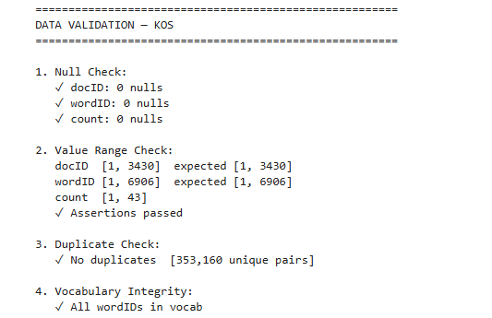
Figure 1: Data Validation
High data integrity (no missing values, valid document and word ID ranges, no two pairs of docID and wordID, complete vocabulary consistency) is ensured by data validation, and preprocessing and modeling can be ensured.
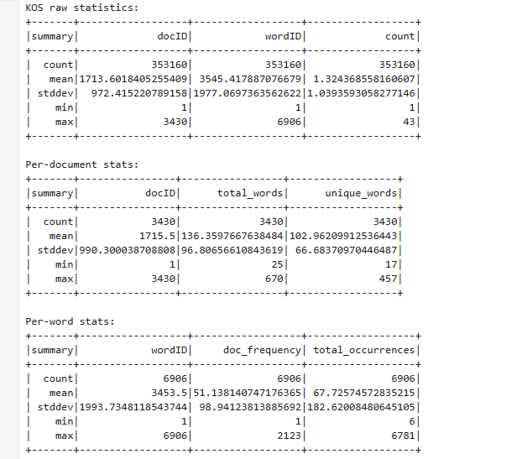
Figure 2: KOS raw statistics
It has a dataset size of 3,430 documents and 6,906 unique words which make up 353,160-word occurrences. The average length of documents is 136 words, and the frequency of words is not distributed evenly, indicating a skewed, Zipf-like distribution which is characteristic of the text corpora.
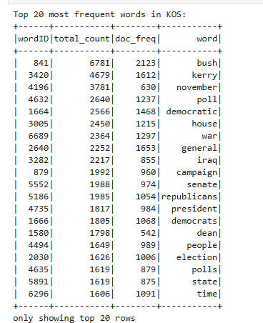
Figure 3: Top 20 most frequent words in KOS
The most common words in KOS include those that are politically oriented, such as Bush, Kerry, democratic, and war, suggesting that the corpus mainly includes the discussion and election campaign as well as the government of the U.S. politics in its coverage.
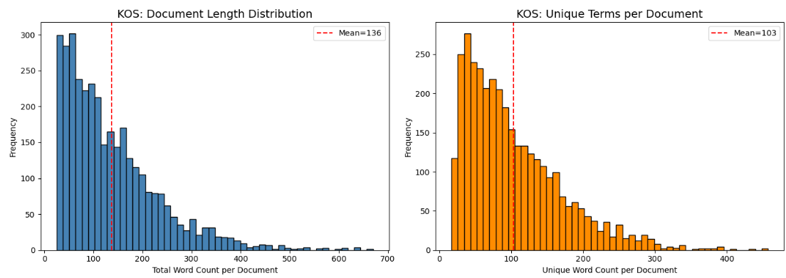
Figure 4: Document Length Distribution
The skewness of the distribution of document length and unique terms displayed in histograms is right-skewed. A majority of the documents are quite short (meaning 136 words and 103 distinct words on average), and some of them are considerably longer.
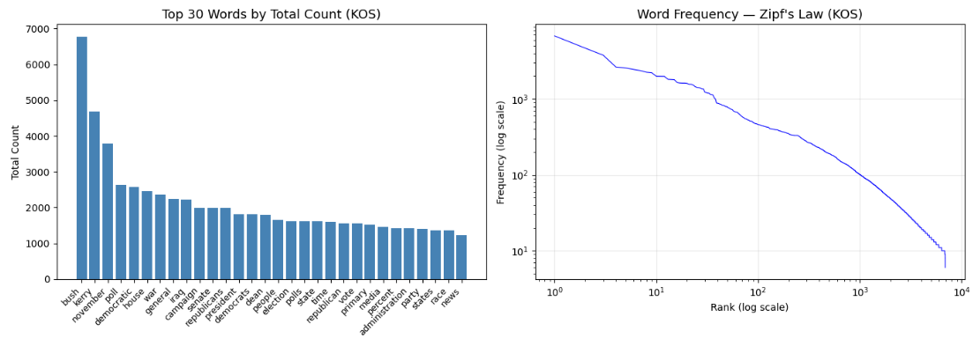
Figure 5: EDA — Word Frequency / Zipf's Law
A bar chart shows the overriding political terms, whereas the use of the log-log plot shows a distinct Zipf-like distribution where very few words are used and the majority of the words are only used a small number of times.
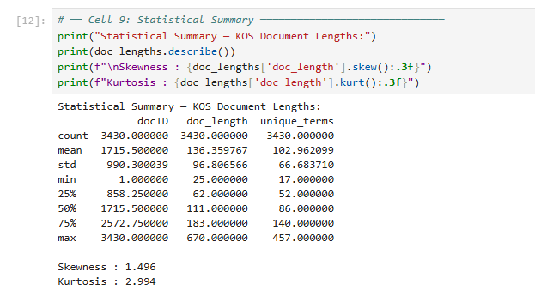
Figure 6: Statistical summary
The statistical summary presents positive skewness values (1.496) and close negative kurtosis (2.994), which indicates that the document lengths are right skewed and there are only a few long outliers, with the majority of documents being concentrated around the mean.

Big Data Challenges
The storage and memory limitations of the high-dimensional sparse text and the large matrices of intermediate features were experienced in the project. Spark distributed processing helped in preventing computational bottlenecks. Partition tuning was made better, and storage overhead was cut by using Parquet compression (Ahmed et al. 2023). Visualization and evaluation were carried out with limited sampling so as to control the consumption of memory.

Methodology

Preprocessing Pipeline
Missing values and duplicates in the data were identified, and the data were verified. The triples of sparse (docID, wordID, count) were transformed into token arrays and computed with TF-IDF to represent the term significance. L2 normalization made the scales of features similar. Principal Component Analysis (PCA) was used to lower the dimensions to 50 components, which enhanced the speed of calculation but did not reduce the variance (Alomari and Mehmood, 2023).

Data Splitting Strategy
A random division (based on a fixed seed) of data into 70% training, 15% validation, and 15% testing-sets was used to encourage reproducibility. Hyperparameter tuning on TrainValidationSplit was used. There was no need for temporal consideration since the dataset is not time-series.

Model Selection & Justification
Scalable clustering was to be used in K-Means and Bisecting K-Means, while interpretable topic modeling was offered in LDA. Gaussian Mixture Models have been used as a probabilistic baseline. The distributed training was done with MLlib, and single-node training with scikit-learn.

Performance Metrics
Self-assessed quality of clustering was done with Silhouette, Davies-Bouldin, and Calinski-Harabasz scores (Alswedani et al. 2022). Tests were executed on a local multi-core Spark installation with optimal partitioning and memory setups.

Computational Considerations
The tests were carried out in a multi-core local machine with the use of PySpark for distributed processing. Partitions were done on memory allocation, shuffle partitions and caching strategies to enhance performance (Heo et al. 2023). The use of parquet storage allowed minimizing the I/O overhead, whereas the repartition ensured the scalability and parallel computation efficiency in training the model.

Results

Experimental Setup
There were experiments on PySpark in a multi-core distributed network with optimised SparkSession settings on memory allocation, caching, and shuffle partitions. TF-IDF and PCA features were trained on four clustering algorithms (KMeans, Bisecting KMeans, LDA and Gaussian Mixture Models) with hyperparameter optimisation. Scalability and results were exported to CSV and visualised in an interactive dashboard of Tableau to compare the results of performance and generate insights.

Model Performance Comparison
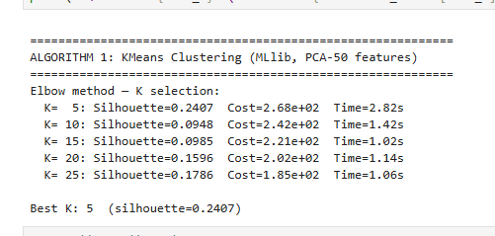
Figure 7: K-means clustering
The algorithm presented the best results, KMeans with PCA-50 features, when using K=5, and yielded the highest silhouette score (0.2407). Clustering quality decreased with increasing K, even at a reduced cost and training time.
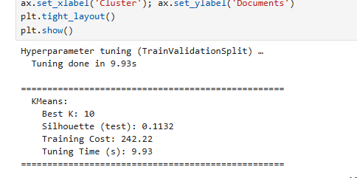
Figure 8: Hyperparameter K-means clustering
TrainValidationSplit hyperparameter selection was used, and K=10 was found to be the best as it has test silhouette= 0.1132, training cost= 242.22. The tuning procedure took 9.93 seconds to achieve a couple of successes.
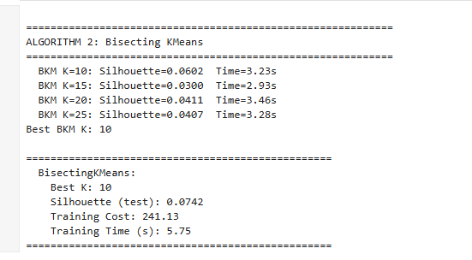
Figure 9: Bisecting Kmeans
The best results of Bisecting KMeans were achieved at K=10 with test silhouette = 0.0742. The training was done in 5.75 seconds and the quality of clustering was worse than normal K-Means.
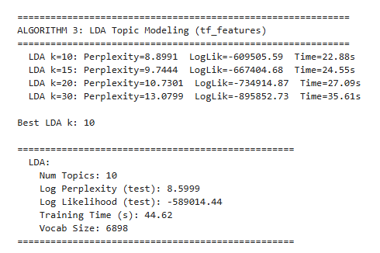
Figure 10: LDA Topic Modelling
LDA topic modeling modelled the data optimally with 10 topics, with the lowest perplexity and the highest log-likelihood. The perplexity of the test logs was 8.5999, and it took about 44.62 seconds of training time on 6,898 vocabulary words.
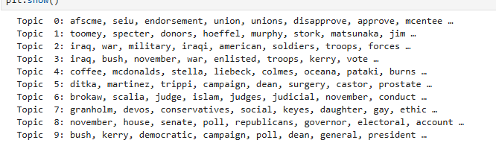
Figure 11: LDA Topics
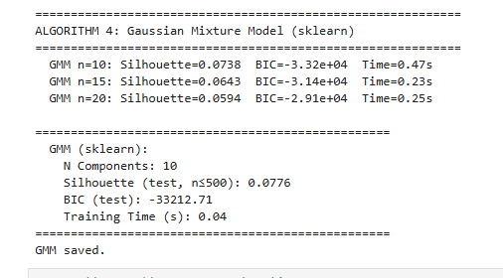
Figure 12: Gaussian Mixture Model
Gaussian Mixture Model was the most successful with 10 components, with a test silhouette score of 0.0776 and minimum BIC. The training time was very rapid and occurred at 0.04 seconds.
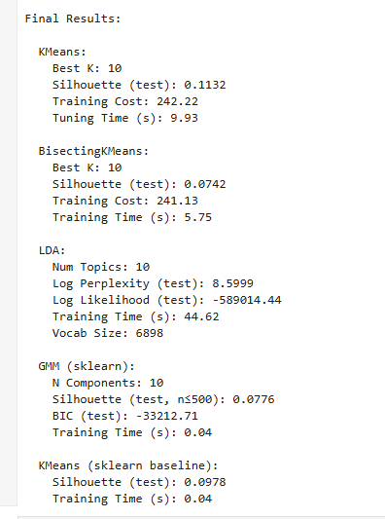
Figure 13: Final Results
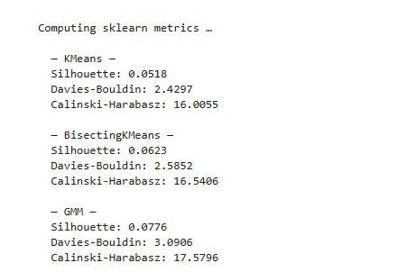
Figure 14: Final Results of Sklearn Metrics
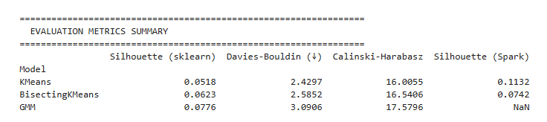
Figure 15: Summary
In the evaluation, the different silhouettes were high with KMeans having the best Spark silhouette of 0.1132 and GMM having the best silhouette on sklearn of 0.0776. The values of Davies-Bouldin and Calinski-Harabasz tell about moderate separation of clusters on the whole.

Visualizations
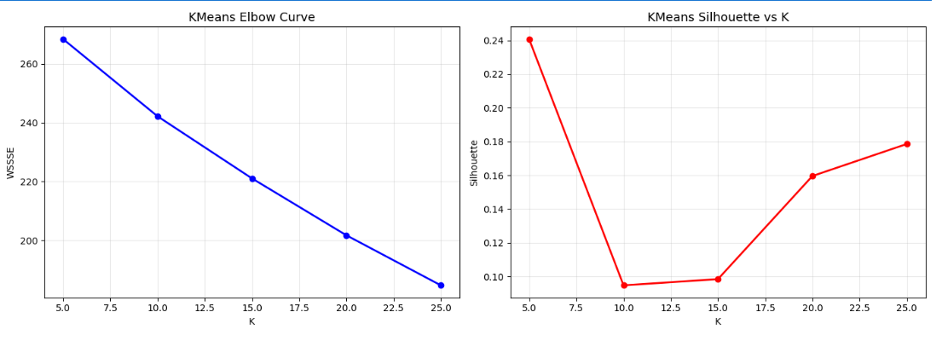
Figure 16: Elbow Plot
Elbow curve records declining WSSSE as K increases, which is a sign of enhanced compactness. The overall score of silhouette however reaches its maximum at K=5, indicating that there are five clusters that offer the optimal balance between cohesion and separation.
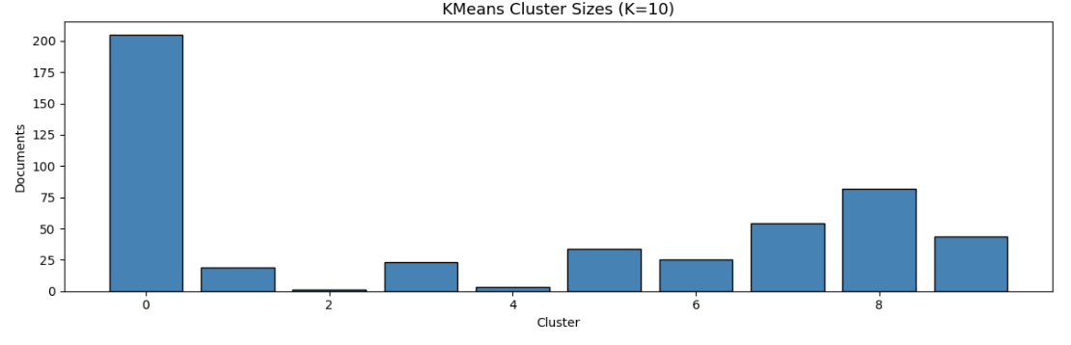
Figure 17: Cluster Sizes
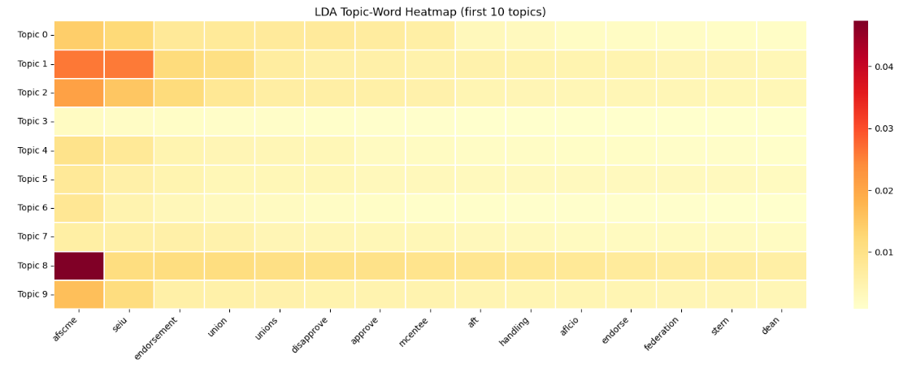
Figure 18: Topic Word Heatmap
The LDA topic-word heatmap reveals clear distributions of terms within each topic, whereby there are some keywords that have a high association with a particular topic, implying that there are meaningful theme separations and readable political topic formations in the corpus.
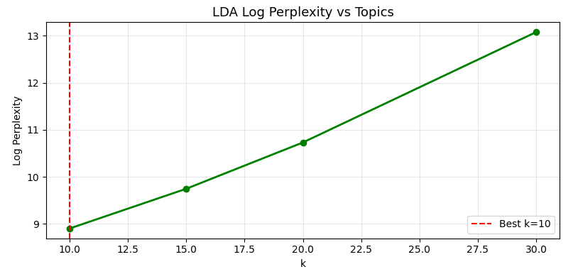
Figure 19: LDA Log Perplexity
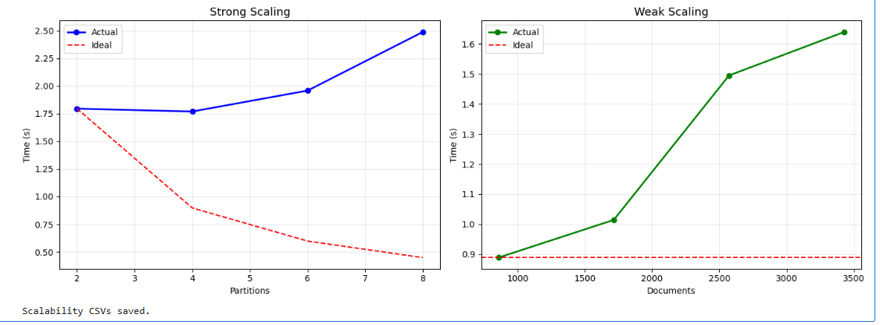
Figure 20: Scaling
Strong scaling exhibits minimal scaling with an increase in partitions, unlike a perfect linear performance. Weak scaling is the increase in training time with the size of the dataset, which shows overheads and resource usage of distributed processing.
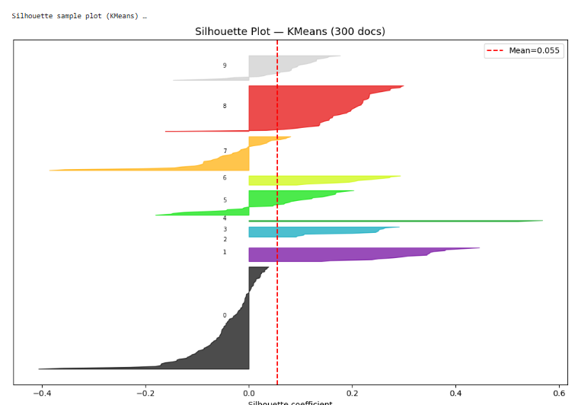
Figure 21: Sample plot
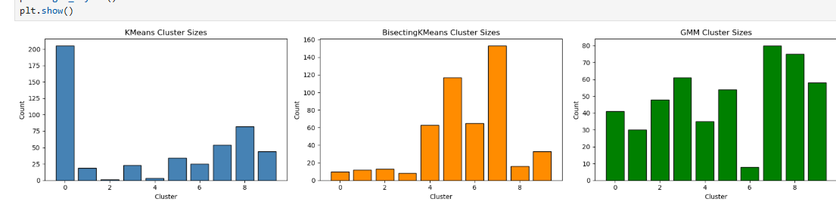
Figure 22: Cluster Sizes plot
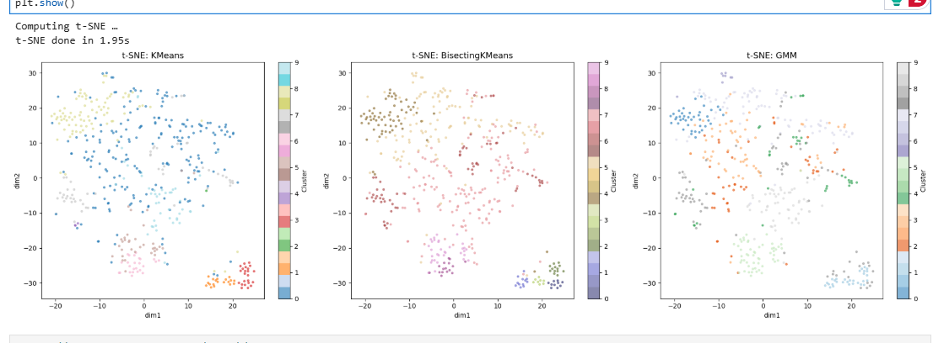
Figure 23: t-SNE plot
The t-SNE plots point to a fair level of cluster separation between KMeans, Bisecting KMeans and GMM. K-Means demonstrates a fairly transparent grouping, whereas other models exhibit overlapping clusters, which suggests poor structural separation.
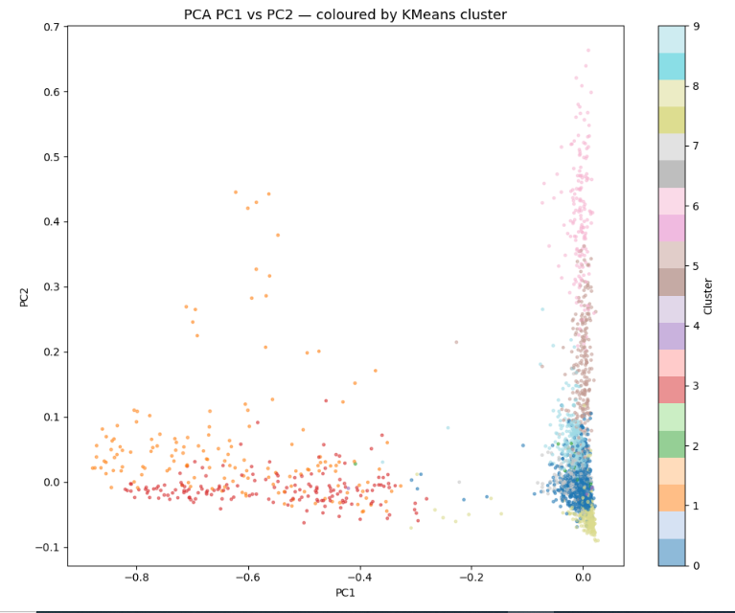
Figure 24: PCA Plot
Tableau Results
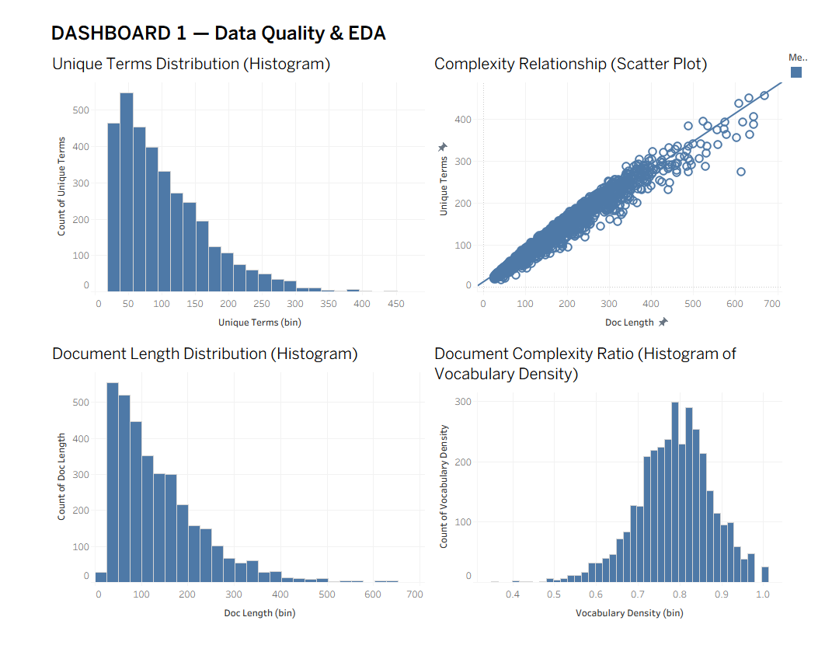
Figure 25: Dashboard 1
Dashboard 1 shows that document length and unique terms are skewed towards the right, and that the length and complexity are strongly positively correlated, and that vocabulary density is high, which is an indicator of a coherent lexical wealth in the documents.
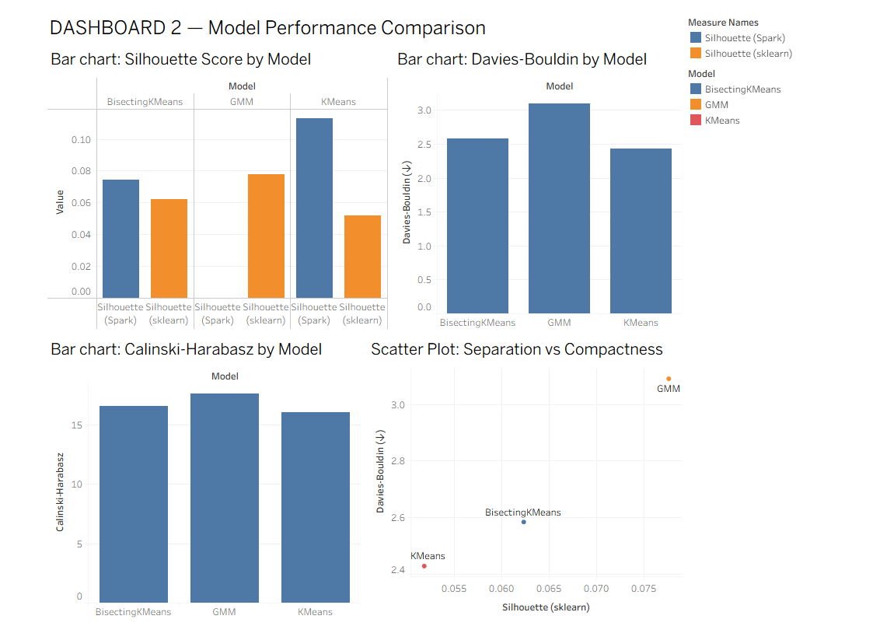
Figure 26: Dashboard 2
Dashboard 2 indicates that KMeans has the best Spark silhouette and competitive Davies-Bouldin values; GMM has the best sklearn silhouette, but with reduced compactness to show performance trade-offs between models.
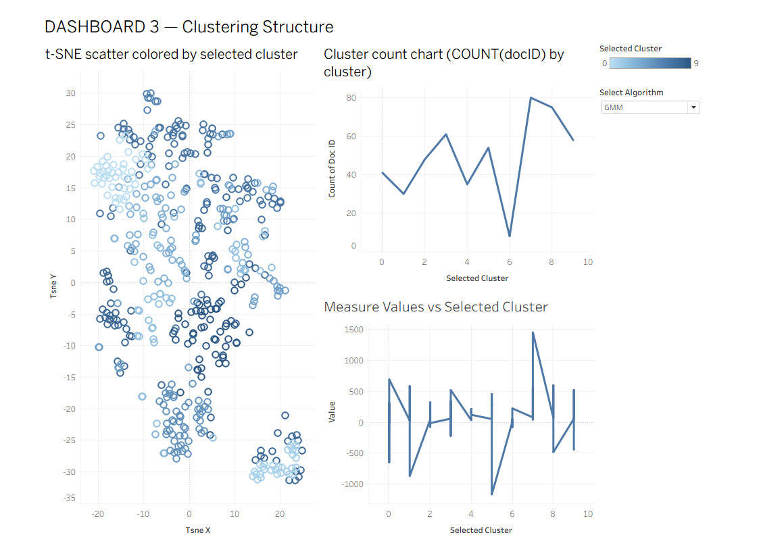
Figure 27: Dashboard 3
Dashboard 3 depicts the cluster configurations of K-Means, Bisecting K-Means, and GMM. K-Means can be seen to be more separated and have a better distribution of the clusters, whereas other algorithms tend to have more overlap and uneven clusters.
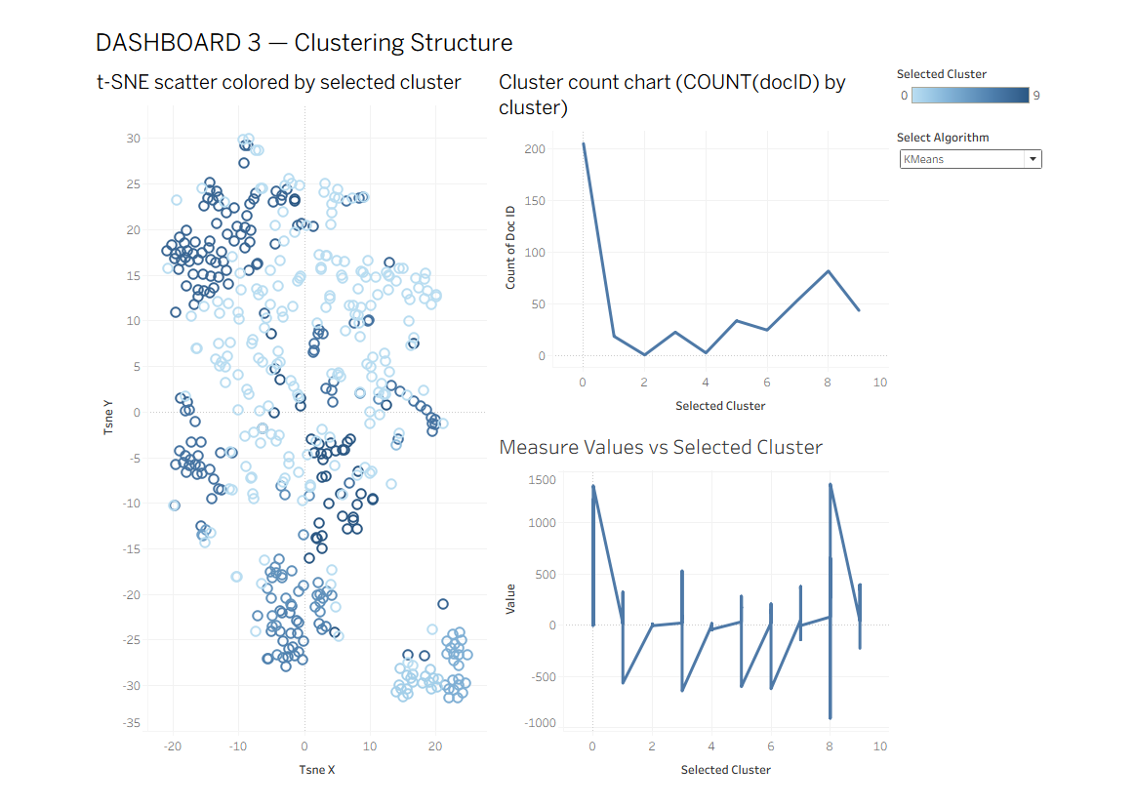
Figure 28: Dashboard 3

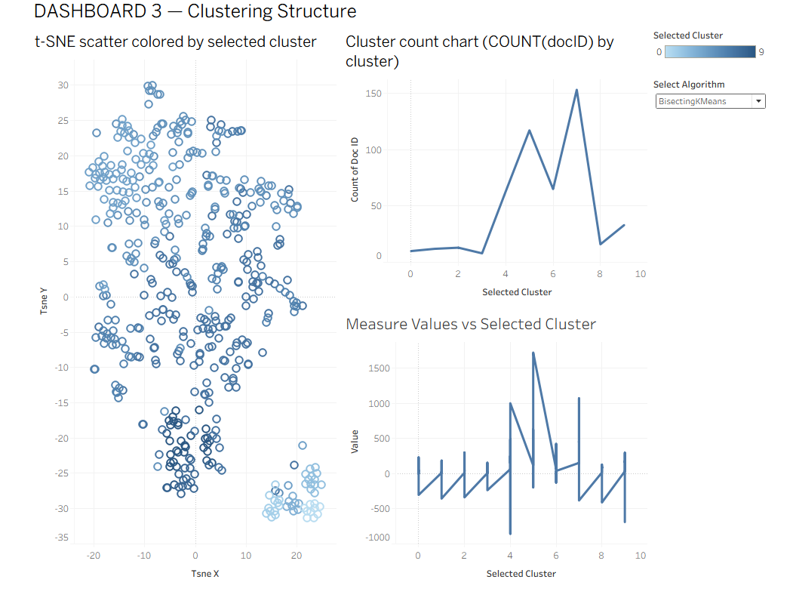
Figure 29: Dashboard 3
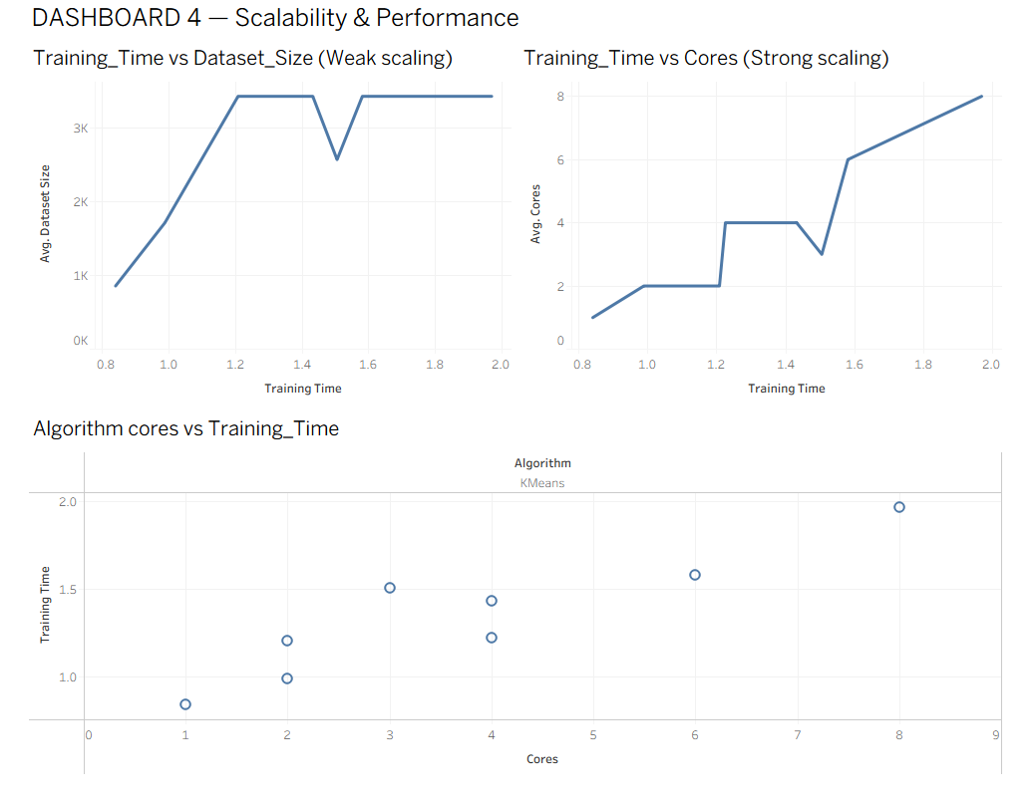
Figure 30: Dashboard 4
Dashboard 4 exhibits scalability behaviour where the training time grows with dataset size in weak scaling and indicates a limited and sub-optimal growth rate in strong scaling, indicating productivity and decreasing parallel efficiency.

Big Data Insights
Scalability experiments indicate that the ratio of the speed of additional cores does not become linear with the additional number of cores because of communication and scheduling overheads. Weak scaling indicates that the time to train increases with the size of the dataset, indicating memory and shuffle constraints (Kvist, 2025). Parquet storage and caching increased I/O efficiency and the gains in parallel were smaller than at levels of modest resource allocation.

Discussion
The findings show that the K-Means algorithm exhibited the best similarity in quality of clustering, as it is consistent with the literature that the centroid number of configurations is useful with TF-IDF representations (Ma et al. 2025). LDA was also interpretable of thematic structures, but more computationally expensive. GMM demonstrated strong probabilistic modeling and weak metrics of separation. Scalability experiments indicated diminishing marginal returns in increasing core allocation, which is in line with the distributed system overhead theory (Salloum et al. 2026). The shortcomings are moderate scores in silhouette, dimensionality reduction dependence, and local cluster availability. Sparse high-dimensional data was computationally difficult during the time of experimentation.

Conclusions & Future Work
This experiment established that distributed PySpark pipelines were useful in scaling text clustering of large, sparse datasets. K-Means offered the optimal performance and efficiency level to the research question about scalable cluster quality. Large-scale analytics became possible with significant improvements in distributed architecture. The framework has real-world uses of text-mining problems related to political topic segmentation. The next steps in the future involve full CrossValidator tuning, benchmarking on bigger, more significant corpora like PubMed, and running the pipeline in a full multi-node cloud environment to achieve better scalability.

References

Ahmed, I., Mia, R. and Shakil, N.A.F., 2023. Mapping blockchain and data science to the cyber threat intelligence lifecycle: Collection, processing, analysis, and dissemination. Journal of Applied Cybersecurity Analytics, Intelligence, and Decision-Making Systems, 13(3), pp.1-37.
Alomari, E.A. and Mehmood, R., 2023. Smart Cities, Smarter Roads: A Review of Leveraging Cutting-Edge Technologies for Intelligent Event Detection from Social Media. International Journal of Advanced Computer Science & Applications, 14(11).
Alswedani, S., Katib, I., Abozinadah, E. and Mehmood, R., 2022. Discovering urban governance parameters for online learning in Saudi Arabia during COVID-19 using topic modeling of twitter data. Frontiers in Sustainable Cities, 4, p.751681.
Heo, S., Kang, D.C., Jang, H., Lee, H.J., Cho, M. and Kim, J.S., 2023. Comprehensive techniques for multi-tenant deep learning framework on a Hadoop YARN cluster. Cluster computing, 26(5), pp.2851-2864.
Kvist, Y., 2025. Distributed Data Parallel Training of Linear Classifiers for Sentiment Analysis on Large Data sets.
Ma, B., Li, H., Hu, Z., Gui, X., Liu, L. and Lau, S., 2025. A Comprehensive Survey of Computer-Driven Recommender System Algorithms: From Traditional Computing to AI-Powered Technologies. Authorea Preprints.
Salloum, S., Tan, K.L. and Huang, J.Z., 2026. A survey of approximate big data computing with the random sample partition (RSP). International Journal of Data Science and Analytics, 21(1), p.35.
Subasi, O., Bel, O., Manzano, J. and Barker, K., 2023. The landscape of modern machine learning: a review of machine, distributed and federated learning. arXiv preprint arXiv:2312.03120.

Appendix

Tableau workbooks
dashboard 1 | Tableau Public
dashboard 2 | Tableau Public
dashboard 3 | Tableau Public
dashboard 4 | Tableau Public

GitHub link
GitHub Link

Additional Result Visualizations

